# Configure MCEBuddy to Accept Remote Connections

|  |  |
| --- | --- |
| Start *MCEBuddy* from the Window Start Menu (on the machine where MCEBuddy is running)  This will open a new window  (*MCEBuddy Status*)  ***Click on the “Settings” button*** |  |

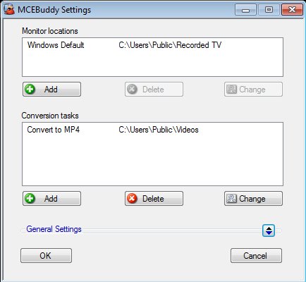

This will open a new window

(*MCEBuddy Settings*)

Click on the “***General Settings”*** button to expand the section

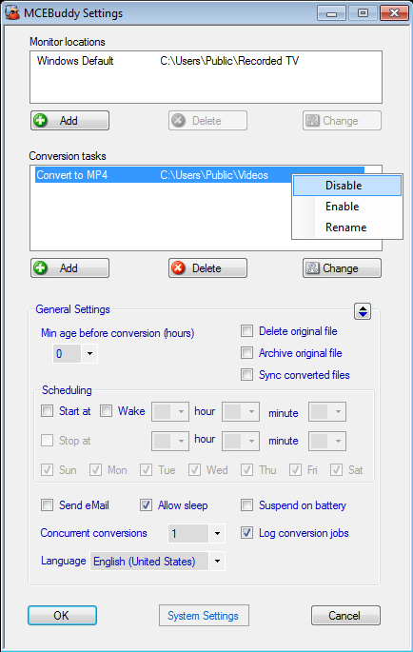

This will expand the *General Settings* section

Click on the “***System Settings***” button

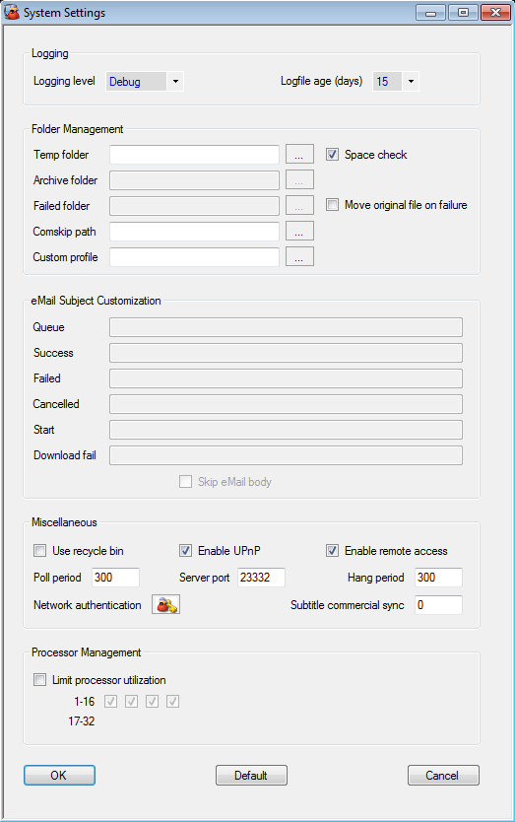

This will open a new window (*System Settings*)

Check the “***Enable UPnP***” box if you are connecting from behind a Home Gateway or Router (e.g. from the Internet)

Check the “***Enable Remote Access***” box

Click on the “***OK***” button



You’re back to the (*MCEBuddy Settings)* page.

Click on the “***OK***” button

# Connecting the MCEBuddy Remote Client

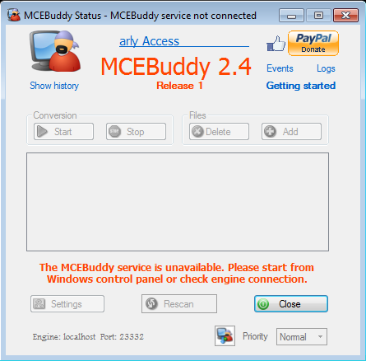

Start *MCEBuddy Remote Client* from the Windows Start Menu on the remote machine

This will open a new window

(*MCEBuddy Status*)

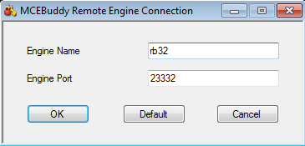

Click on the “***OK***” button

Enter the *Name* or *IP Address* of the computer where the MCEBuddy Engine is running

e.g. *rb32* or *192.168.1.34*

Click on this “***Icon”*** to enter the details of the MCEBuddy Engine you want to connect to.

This will open a new window

(*MCEBuddy Remote Engine Connection*)

# 

This shows the *Name* and *Port* number of the MCEBuddy Engine the Remote Client is trying/is connected to

**You’re All Set!**

If you have any files in the “*Monitor Locations*” folder, they should start converting automatically